


DAYANANDA SAGAR UNIVERSITY
HAROHALLI, KANAKAPURA ROAD – 562112
DEPARTMENT OF COMPUTER SCIENCE & ENGINEERING
(DATA SCIENCE)
DevOps PROJECT REPORT
ON
" JobFindr - Job Recommendation Engine"
2025-2026
BACHELOR OF TECHNOLOGY
IN
COMPUTER SCIENCE & ENGINEERING (DATA SCIENCE)

Submitted by
Vedula Narasimha Bharadwaj – ENG23DS0092
Varun K Chavda – ENG23DS0091
Om Singh – ENG23DS0133

Under The Supervision of:
Prof. Jobin Thomas, Assistant Professor
Computer Science & Engineering (Data Science)

DAYANANDA SAGAR UNIVERSITY
SCHOOL OF ENGINEERING
Devarakaggalahalli, Harohalli,
Kanakapura Road, Dt. Bangalore South,

Karnataka -562112

CERTIFICATE
This is to certify that the Mini Project titled “JobFindr - Job Recommendation Engine” has been carried out by VARUN K CHAVDA – ENG23DS0091, VEDULA NARASIMHA BHARADWAJ – ENG23DS0092, OM SINGH – ENG23DS0113 Bonafide students of Bachelor of Technology in Computer Science and Engineering (Data Science) at the School of Engineering, Dayananda Sagar University, Bangalore, in partial fulfilment of the requirements for the award of the degree of Bachelor of Technology in Computer Science and Engineering (Data Science) during the academic year 2025–2026. It is further certified that all corrections and suggestions indicated during the internal assessment have been incorporated in the final report submitted to the departmental library. The project report has been approved as it satisfies the academic requirements in respect of the project work for the said degree.
Prof. Jobin Thomas |  | 
Assistant Professor  Dept. Of CSE (Data Science)  School of Engineering Dayananda Sagar University  Date: | Professor  Dept. Of CSE (Data Science) School of Engineering  Dayananda Sagar University Date: | Dean  School of Engineering  Dayananda Sagar University  Date:

Name of the Examiner Signature of Examiner

DECLARATION

We, Varun K Chadva – ENG23DS0091, Vedula Narasimha Bharadwaj – ENG23DS0092, Om Singh – ENG23DS0113 are students of Sixth semester B.Tech in Computer Science and Engineering (Data Science), at School of Engineering, Dayananda Sagar University, hereby declare that the Major Project titled “JobFindr - Job Recommendation Engine” has been carried out by us and submitted in partial fulfilment for the award of degree in Bachelor of Technology in Computer Science and Engineering (Data Science) during the academic year 2025- 2026

\

Name 1: Varun K Chadva
USN : ENG22DS0091

Name 2: Vedula Narasimha Bharadwaj
USN : ENG23DS0092

Name 3: Om Singh
USN : ENG23DS0113

Place : Bengaluru

Date:

ACKNOWLEDGEMENT

It is a great pleasure for us to acknowledge the assistance and support of many individuals who have been responsible for the successful completion of this project work. First, we take this opportunity to express our sincere gratitude to School of Engineering & Technology. Dayananda Sagar University for providing us with a great opportunity to pursue our Bachelor's degree in this institution.

We would like to thank Dr. Udaya Kumar Reddy K. R. Dean, School of Engineering & Technology, Dayananda Sagar University for his constant encouragement and expert advice.

It is a matter of immense pleasure to express our sincere thanks to Dr. Shaila S G. Department Chairperson, Computer Science and Engineering (Data Science), Dayananda Sagar University, for providing right academic guidance that made our task possible.

We would like to thank our guide Prof. Jobin Thomas., Dept. of Computer Science and Engineering (Data Science), Dayananda Sagar University for sparing her valuable time to extend help in every step of our project work, which paved the way for smooth progress and the fruitful culmination of the project.

We would like to thank one and all who directly or indirectly helped us in the Project work.

SIGNATURE:

VEDULA NARASIMHA BHARADWAJ - ENG23DS0092
OM SINGH - ENG23DS0113
VARUN K CHAVDA - ENG23DS0091

TABLE OF CONTENTS
CHAPTER 1 INTRODUCTION…………………………………………………….
CHAPTER 2 PROBLEM STATEMENT……………………………………………
CHAPTER 3 REQUIREMENTS 03
CHAPTER 4 METHODOLOGY……………………………………………………05
CHAPTER 5 IMPLEMENTATION 08
CHAPTER 6 RESULTS AND OUTPUT…………..……………………………….10
CHAPTER 7 CONCLUSION 14

INTRODUCTION

In today’s rapidly evolving digital economy, the job market has become highly dynamic, competitive, and information-intensive. With thousands of job postings being added daily across various platforms, job seekers often face significant challenges in identifying opportunities that align with their skills, experience, and career aspirations. Traditional job search methods rely heavily on manual filtering and keyword-based searches, which are not only time-consuming but also inefficient in capturing the semantic relevance between a candidate’s profile and job descriptions.
To address these limitations, intelligent recommendation systems have emerged as a powerful solution. These systems leverage techniques from Natural Language Processing (NLP), Information Retrieval, and Machine Learning to analyze textual data and provide personalized suggestions. By understanding both user profiles and job descriptions at a deeper level, such systems can significantly enhance the job discovery process.
The JobFindr – Job Recommendation Engine is designed as a smart and scalable solution that automates the process of matching candidates with relevant job opportunities. The system utilizes advanced text processing techniques, including Term Frequency–Inverse Document Frequency (TF-IDF) for feature extraction, combined with similarity-based algorithms such as cosine similarity and keyword matching methods. Additionally, a hybrid recommendation approach is implemented to improve the accuracy and robustness of job suggestions by integrating multiple scoring mechanisms.
A key highlight of this project is its ability to process user resumes and extract meaningful information such as skills, experience, and preferences. This information is then used to generate personalized recommendations based on multiple dimensions, including skill compatibility, salary expectations, and job seniority levels. Furthermore, the system incorporates visualization techniques to provide intuitive insights into recommendation results.
Overall, the JobFindr system aims to bridge the gap between job seekers and recruiters by delivering precise, efficient, and data-driven job recommendations. It not only improves user experience but also demonstrates the practical application of machine learning and NLP techniques in solving real-world problems in the recruitment domain.

PROBLEM STATEMENT

In today’s digital recruitment landscape, job seekers are exposed to an overwhelming number of job listings across various online platforms. Identifying relevant opportunities that align with an individual’s skills, experience, and career preferences has become increasingly difficult due to the sheer volume and diversity of available data. Traditional job search systems primarily rely on basic keyword matching and manual filtering, which often fail to capture the semantic meaning and contextual relevance between a candidate’s profile and job descriptions. As a result, users frequently receive irrelevant recommendations, leading to inefficiency, time consumption, and missed career opportunities.

Moreover, existing systems lack the capability to effectively process unstructured data such as resumes and job descriptions, which contain valuable information in textual form. They do not adequately consider multiple important factors such as skill compatibility, experience level, salary expectations, and job seniority while generating recommendations. This limitation results in a poor user experience and reduces the effectiveness of the job search process, especially for candidates seeking personalized and accurate suggestions.

Therefore, there is a need to develop an intelligent job recommendation system that can analyze and interpret textual data using advanced techniques such as Natural Language Processing and Machine Learning. The system should be capable of extracting meaningful features from resumes and job descriptions, computing similarity scores using efficient algorithms, and generating personalized, accurate, and multi-dimensional job recommendations. The proposed solution aims to address these challenges by providing a smart, scalable, and data-driven platform that improves the overall efficiency and effectiveness of job matching.

OBJECTIVES:

- To develop an intelligent job recommendation system that efficiently matches job seekers with relevant job opportunities based on their skills, experience, and preferences.

- To preprocess and analyze large volumes of unstructured job data, converting it into a structured format suitable for machine learning and recommendation techniques.

- To implement Natural Language Processing (NLP) methods such as TF-IDF vectorization for effective feature extraction from job descriptions and user profiles.

- To apply similarity measurement techniques, including cosine similarity and Jaccard similarity, to evaluate the relevance between jobs and candidate profiles.

- To design and implement a hybrid recommendation model that combines multiple algorithms to improve accuracy and reliability of job suggestions.

- To incorporate a multi-dimensional scoring mechanism that evaluates job matches based on various factors such as skill compatibility, salary alignment, seniority level, and job demand.

- To generate personalized and ranked job recommendations that enhance the efficiency and user experience of the job search process.

- To analyze and visualize the performance of different recommendation approaches using graphical techniques for better interpretation and evaluation.

- To build a scalable and adaptable system that can be extended with advanced techniques such as deep learning and real-time data integration in the future.

DATASET

Dataset Used :
The dataset used in the JobFindr – Job Recommendation Engine consists of 500 job listings containing information related to job roles, companies, departments, locations, and textual descriptions. This dataset is designed to simulate real-world recruitment data and provides a diverse collection of job postings across multiple domains such as Engineering, Design, Backend, Security, and Data Science. The dataset includes both structured attributes (e.g., job title, company name) and unstructured textual data (e.g., job descriptions and required skills), making it suitable for applying Natural Language Processing (NLP) techniques. The diversity and size of the dataset enable effective training and evaluation of recommendation algorithms.

Source of Dataset:
The dataset is sourced from Kaggle, a widely used platform for accessing high-quality datasets for machine learning and data science applications. Kaggle provides real-world datasets contributed by organizations and researchers, ensuring reliability and relevance. The dataset used in this project has been curated to include various job categories and skill requirements, making it ideal for developing and testing a job recommendation system.

Description of Features
The dataset contains several important features that are utilized for analysis and recommendation:
- Job ID: A unique identifier assigned to each job listing, used for indexing and reference.
- Job Title: Specifies the name of the job position (e.g., Data Scientist, Software Engineer), which plays a key role in understanding the job role.
- Company Name: Indicates the organization offering the job, providing contextual information about the employer.
- Department: Represents the domain or category of the job, such as Engineering, Design, or Data Science, which is useful for classification and filtering.
- Location: Specifies the geographical location of the job, helping users identify opportunities based on preferred regions.
- Job Description: A textual field containing detailed information about the job role, responsibilities, and requirements. This is a crucial feature used for NLP processing and TF-IDF vectorization.
- Skills (Extracted/Derived): Represents key skills required for the job, either explicitly present in the dataset or extracted during preprocessing. This feature is used for keyword matching and similarity computation.

METHODOLOGY

The JobFindr – Job Recommendation Engine follows a comprehensive and multi-layered methodology that integrates data preprocessing, Natural Language Processing (NLP), feature extraction, similarity computation, and hybrid recommendation techniques to deliver accurate and personalized job suggestions. The methodology is designed to handle unstructured textual data efficiently while ensuring scalability and relevance in real-world job matching scenarios.

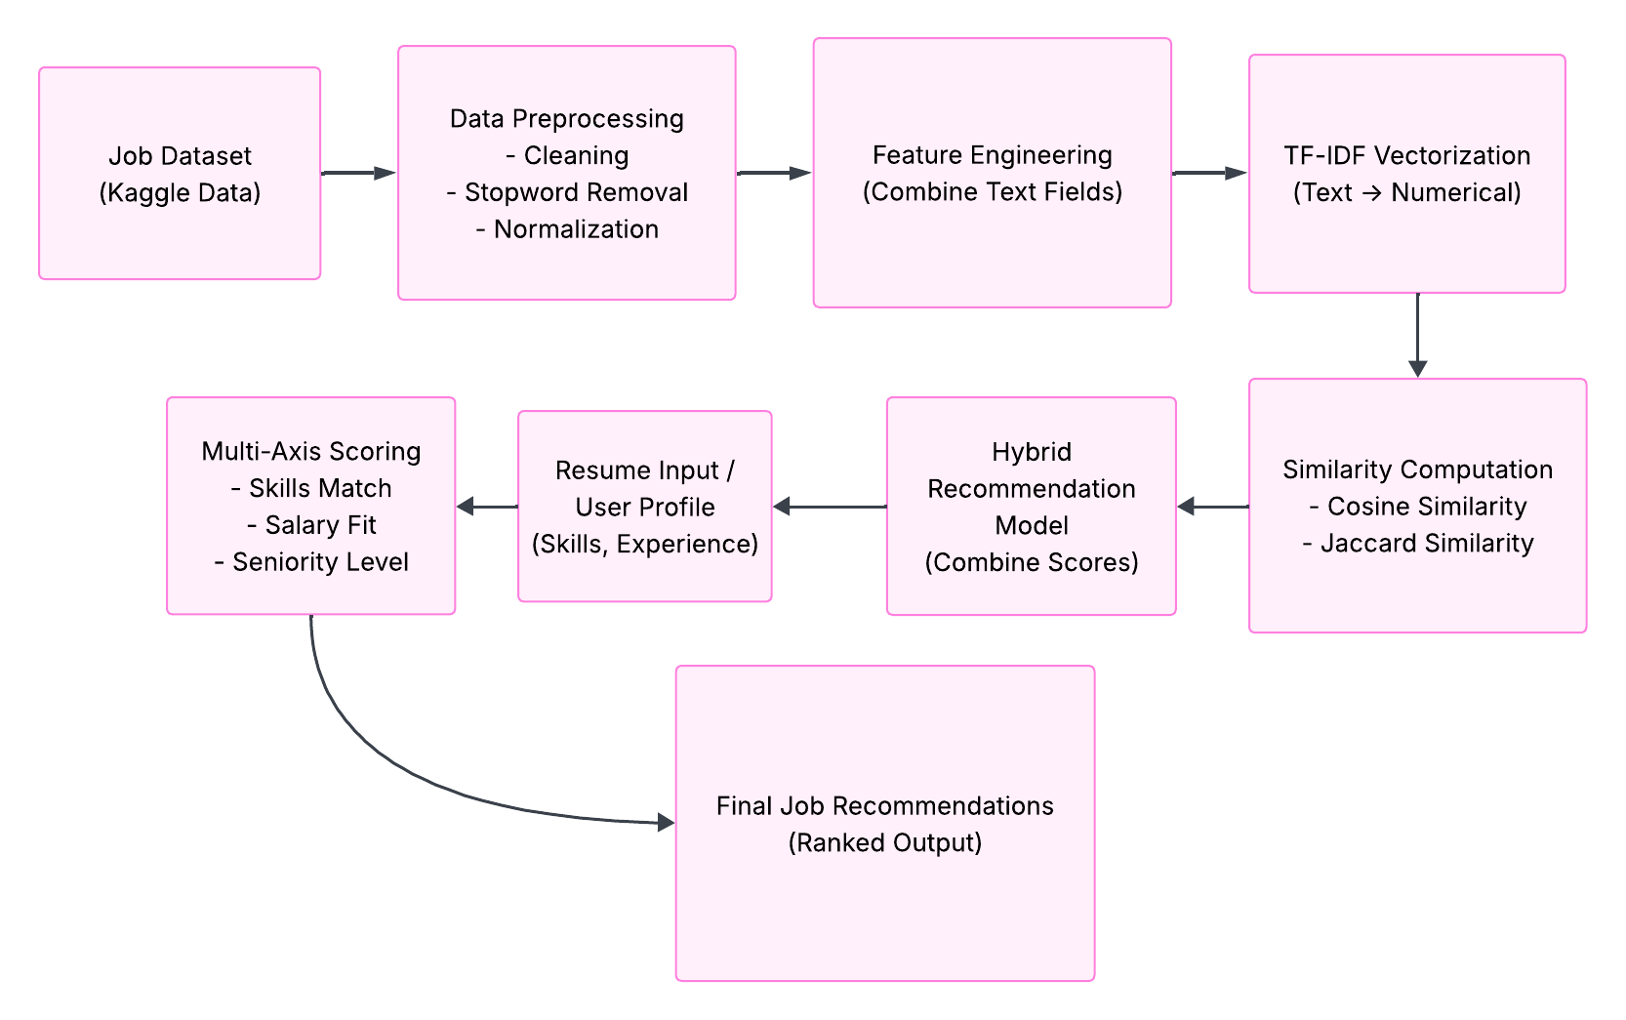
Fig 1: Data preprocessing and cleaned dataset

The process begins with data acquisition and preprocessing, where the dataset is obtained from Kaggle and loaded into the system using Python-based data handling libraries. Since job-related datasets typically contain noisy and unstructured information, extensive preprocessing is performed to enhance data quality. This includes handling missing values, removing duplicate entries, filtering irrelevant attributes, and standardizing textual content. Text normalization techniques such as converting all characters to lowercase, removing punctuation, eliminating stopwords, and applying tokenization are used to clean the data. Furthermore, key attributes such as job title, required skills, and job description are combined to form a single consolidated textual feature, ensuring that all relevant information contributes to the recommendation process.

Once the data is cleaned and structured, the next phase involves feature engineering and representation. Given that the data is primarily textual, it must be transformed into a numerical format that machine learning models can process. For this purpose, the Term Frequency–Inverse Document Frequency (TF-IDF) technique is employed. TF-IDF evaluates the importance of each word in a document relative to the entire dataset by assigning higher weights to unique and informative terms while reducing the influence of commonly occurring words. This transformation results in a high-dimensional sparse matrix where each job listing is represented as a vector. This vectorized representation serves as the foundation for similarity-based comparisons.

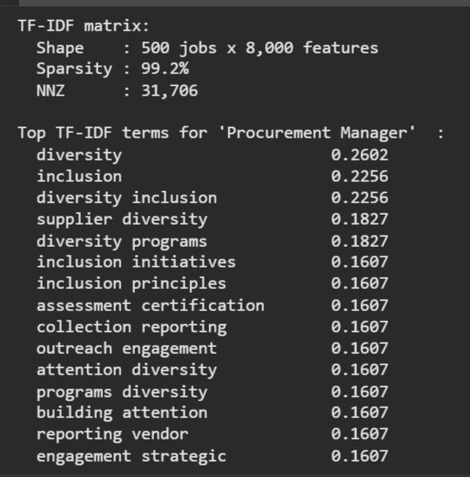

Fig 2: TF-IDF vector representation

Following feature extraction, the methodology incorporates similarity measurement techniques to identify relationships between job descriptions and user profiles. The primary method used is cosine similarity, which computes the cosine of the angle between two vectors in a multi-dimensional space. A higher cosine similarity value indicates a stronger relationship between two documents, enabling the system to rank jobs based on their relevance to the user’s input. In addition to cosine similarity, a keyword-based similarity approach using Jaccard similarity is implemented. This method compares sets of skills extracted from job descriptions and user resumes, calculating the ratio of common elements to the total unique elements. This ensures that exact skill matches are also considered alongside semantic similarity.

To further enhance the recommendation quality, the system adopts a hybrid recommendation model that combines multiple similarity measures. The hybrid approach integrates TF-IDF-based cosine similarity with Jaccard similarity scores to leverage both contextual understanding and precise keyword matching. By assigning appropriate weights to each component, the system generates a more balanced and accurate recommendation score. This approach addresses the limitations of individual methods and improves overall system robustness.

$$cos⁡(θ)=\frac{A⋅B}{∥A∥∥B∥}=\frac{\sum_{i=1}^{n}{A_{i}}B_{i}}{\sqrt{\sum_{i=1}^{n}{A_{i}^{2}}}⋅\sqrt{\sum_{i=1}^{n}{B_{i}^{2}}}}$$

An essential component of the methodology is resume parsing and user profiling. The system processes user-provided input, such as resumes or skill sets, to extract meaningful features including technical skills, experience level, and job preferences. This information is then used to create a user profile vector that can be compared against job listings. Advanced text processing techniques are applied to identify relevant keywords and categorize them effectively, ensuring that the system understands the user’s qualifications and expectations.

In addition to similarity-based matching, the methodology incorporates a multi-dimensional scoring mechanism to evaluate job recommendations across several critical factors. These include skill compatibility, salary range alignment, and job seniority level. Each factor is assigned a score based on predefined criteria, and these scores are aggregated to compute a final ranking. This multi-axis evaluation ensures that recommendations are not only relevant in terms of skills but also aligned with the user’s career goals and expectations.

$$Score=w_{1}⋅S_{skills}+w_{2}⋅S_{salary}+w_{3}⋅S_{seniority}$$
Here:
- $S_{skills}$= Skill matching score
- $S_{salary}$= Salary compatibility score
- $S_{seniority}$= Seniority level score
- $w_{1},w_{2},w_{3}$= Weights assigned to each factor (based on importance)

Finally, the methodology includes result visualization and interpretation, which plays a crucial role in analyzing the system’s performance. Visualization tools are used to generate graphs and plots that illustrate similarity distributions, ranking patterns, and recommendation outcomes. These visual insights help in validating the effectiveness of the model and provide a clearer understanding of how different components contribute to the final recommendations.

Overall, the methodology of the JobFindr system is designed to provide a robust, scalable, and intelligent framework for job recommendation. By combining advanced NLP techniques, hybrid similarity models, and multi-dimensional evaluation, the system effectively bridges the gap between job seekers and relevant employment opportunities, offering a data-driven solution to modern recruitment challenges.

IMPLEMENTATION

The implementation of the JobFindr – Job Recommendation Engine is carried out using Python within the Google Colab environment, which provides a flexible and efficient platform for executing data processing, machine learning, and visualization tasks. The system is designed as a modular pipeline, where each stage contributes to transforming raw job data into meaningful and ranked recommendations.

The implementation begins with data loading and preprocessing, where the dataset is imported using the pandas library. The dataset undergoes extensive cleaning to ensure data quality and consistency. Missing values are handled appropriately, duplicate entries are removed, and only relevant columns such as job title, company, department, and description are retained. Textual fields are then normalized by converting to lowercase, removing punctuation, eliminating stopwords, and applying tokenization. Furthermore, multiple text-based attributes such as job descriptions and required skills are merged into a single consolidated feature column. This unified representation allows the system to capture the complete semantic context of each job entry.

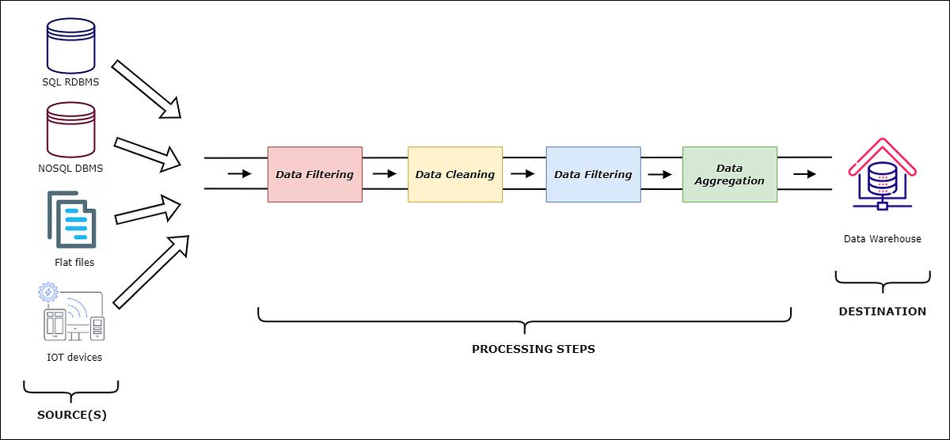

Fig 3: Implementaion Algorithm

Following preprocessing, the system performs feature extraction using TF-IDF (Term Frequency–Inverse Document Frequency) through the scikit-learn library. This step converts textual data into a numerical matrix, where each row represents a job and each column represents a term weighted by its importance. The TF-IDF weighting is defined as:

$$TF\text{-}IDF(t,d)=TF(t,d)⋅log⁡\left(\frac{N}{DF(t)}\right)$$

where $TF(t,d)$represents the frequency of term $t$in document $d$, $DF(t)$is the number of documents containing the term, and $N$is the total number of documents. This transformation ensures that commonly occurring words are down-weighted while informative terms are emphasized, enabling effective numerical representation of textual data.

Once the TF-IDF matrix is generated, the implementation proceeds to similarity computation using cosine similarity. This technique calculates the similarity between job vectors and user input vectors by measuring the cosine of the angle between them. The cosine similarity is defined as:

$$cos⁡(θ)=\frac{A⋅B}{∥A∥∥B∥}$$
where $A$and $B$represent the TF-IDF vectors of the job description and user profile. A higher cosine value indicates greater similarity. In parallel, the system implements a keyword-based matching mechanism using Jaccard similarity, which compares the similarity between two sets of skills:

$$J(A,B)=\frac{∣A∩B∣}{∣A∪B∣}$$

This dual approach ensures that both semantic similarity (via TF-IDF) and exact keyword overlap (via Jaccard similarity) are considered during recommendation generation.

To improve recommendation accuracy, a hybrid recommendation model is implemented by combining TF-IDF cosine similarity scores with Jaccard similarity scores. The hybrid scoring function is expressed as:

$$Score=α⋅Cosine(A,B)+(1-α)⋅J(A,B)$$

where $α$is a weighting factor that balances the contribution of semantic similarity and keyword matching. This approach overcomes the limitations of individual methods by integrating both contextual understanding and precise skill matching, resulting in more accurate and robust recommendations.

An important component of the implementation is the resume parsing and user profiling module. The system accepts user input in the form of skills or resume text and processes it using similar preprocessing techniques applied to job descriptions. Relevant features such as technical skills, experience level, and job preferences are extracted and transformed into a vector representation. This user profile is then compared with job vectors to generate personalized recommendations.

To further refine the results, the system employs a multi-dimensional scoring mechanism, where job recommendations are evaluated across several axes, including skill match, salary compatibility, and seniority level. The final ranking score is computed using a weighted aggregation:

$$FinalScore=w_{1}S_{skills}+w_{2}S_{salary}+w_{3}S_{seniority}$$

where $S_{skills}$, $S_{salary}$, and $S_{seniority}$represent individual scores, and $w_{1},w_{2},w_{3}$are their respective weights. This ensures that recommendations are not only textually relevant but also aligned with practical job requirements and user expectations.

Finally, the implementation incorporates data visualization techniques using Matplotlib and Seaborn. Various plots, including score distributions, similarity graphs, and comparison charts, are generated to analyze the performance of the recommendation system.
RESULTS AND OUTPUT

The exploratory analysis of the job dataset reveals a significant imbalance in department distribution, with the Engineering domain dominating the dataset by a large margin. Other departments such as Design, Backend, and Security have comparatively moderate representation, while specialized fields like Machine Learning and Data Engineering appear in very limited numbers. This indicates a higher demand for general engineering roles and suggests that the dataset is skewed toward broader technical positions.

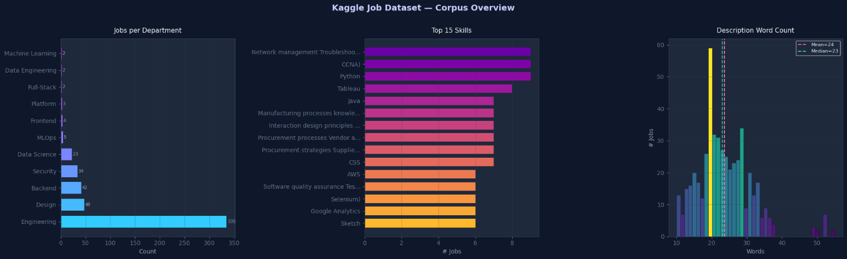

Fig 4: Job distribution, skills, and description insights

The skill analysis highlights the prominence of technical and analytical skills such as Python, CCNA, Java, Tableau, and AWS, reflecting current industry demands. Additionally, the distribution of job description word counts shows that most entries fall within a consistent range, with closely aligned mean and median values. This uniformity in text length supports effective TF-IDF processing and ensures balanced similarity computation across job postings.

The comparative analysis of recommendation algorithms across different user profiles demonstrates clear performance differences between TF-IDF, keyword-based, and hybrid approaches. For the first user profile, Alex Chen (AI Specialist), the TF-IDF model achieves high similarity scores for relevant roles such as Data Scientist, indicating strong semantic understanding of job descriptions. However, the keyword-based approach shows comparatively lower scores due to its reliance on exact term matching. The hybrid model balances both approaches and produces slightly improved and more consistent results, ensuring better alignment with the user’s profile.

For the second profile, Priya Sharma (Full Stack Developer), a similar trend is observed where TF-IDF effectively captures contextual relevance, particularly for web development roles. The keyword-based method performs moderately but lacks consistency across different job types. The hybrid approach again demonstrates improved performance by integrating both semantic similarity and keyword overlap, resulting in more reliable recommendations across multiple job categories, including Web Developer and related roles.

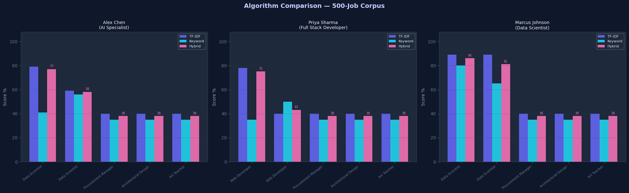

Fig 5: Comparison of TF-IDF, keyword, hybrid scores

In the case of Marcus Johnson (Data Scientist), the results show the highest scores overall, with TF-IDF and hybrid models performing exceptionally well for data-centric roles. The keyword-based approach shows better performance here compared to other profiles due to clearer skill alignment. However, the hybrid model still provides the most balanced output, combining high semantic relevance with strong keyword matching. Overall, the results confirm that the hybrid recommendation model consistently outperforms individual approaches by delivering more accurate and stable recommendations across diverse user profiles.

The multi-dimensional scoring analysis provides a deeper understanding of how the hybrid recommendation system evaluates job matches across multiple parameters. For Alex Chen (AI Specialist), the radar chart indicates a very strong match score, along with high demand and moderate alignment in role and seniority. However, the salary fit is comparatively lower, suggesting that while the job is highly relevant in terms of skills and demand, it may not fully meet salary expectations. This highlights the importance of considering multiple factors rather than relying solely on similarity scores.

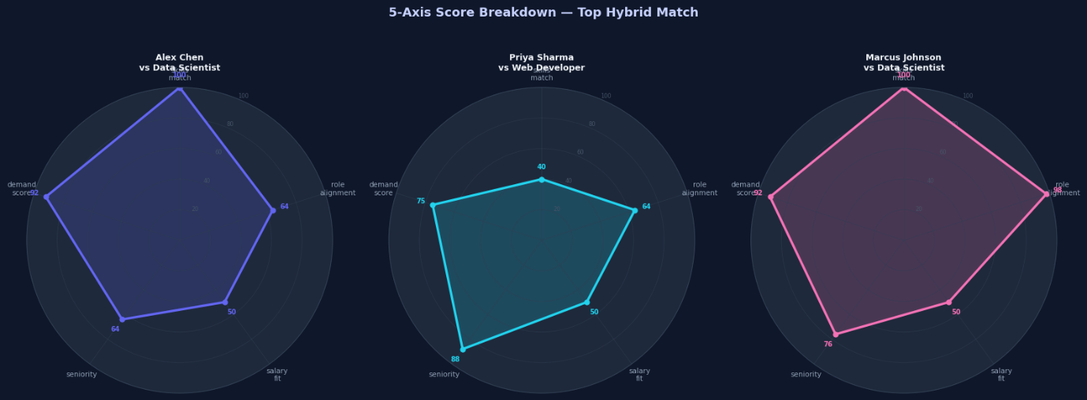

Fig 6: Multi-dimensional hybrid scoring radar comparison

For Priya Sharma (Full Stack Developer), the results show a balanced distribution across different dimensions. While the match score is moderate, the system identifies strong seniority alignment and good demand in the job market. Role alignment is also reasonably high, indicating that the recommended job fits her professional background. However, similar to the previous case, salary fit remains relatively lower, suggesting a potential mismatch in compensation expectations despite a suitable role match.

In the case of Marcus Johnson (Data Scientist), the radar chart demonstrates the strongest overall performance among the three profiles. The system achieves near-perfect scores in match and role alignment, along with high demand and strong seniority compatibility. Although the salary fit is slightly lower compared to other factors, the overall balance of high scores across all dimensions confirms the effectiveness of the hybrid model in identifying highly relevant job opportunities. These results validate that the multi-dimensional scoring mechanism successfully enhances recommendation quality by incorporating diverse evaluation criteria.

The score distribution analysis provides insights into how different recommendation approaches perform across the dataset. The match score distribution shows that the majority of job recommendations fall within a moderate score range, indicating that most jobs have a reasonable level of relevance to the user profile. The TF-IDF and hybrid approaches demonstrate a more concentrated distribution, suggesting consistent performance, while the keyword-based method shows slightly more variation due to its dependence on exact term matching.

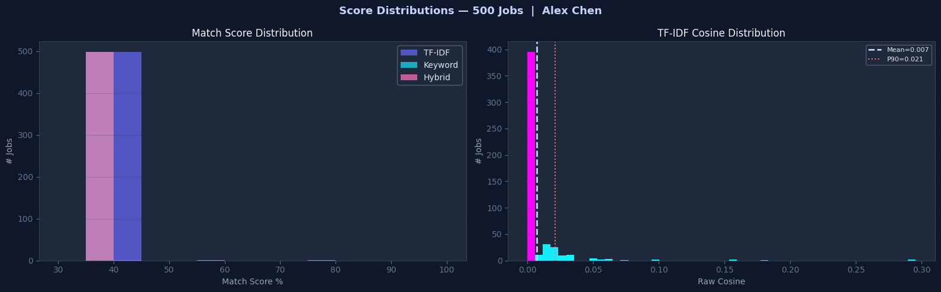

Fig 7: Score distribution and TF-IDF cosine analysis

The TF-IDF cosine similarity distribution further highlights the behavior of the model in measuring textual similarity. Most similarity values are clustered near lower ranges, which is expected in high-dimensional text data, where only a few documents exhibit strong similarity. The presence of mean and percentile indicators shows that only a small portion of jobs achieve high similarity scores, making them strong candidates for recommendation. This reflects the effectiveness of TF-IDF in distinguishing relevant jobs from a large pool of options.

Overall, the hybrid model benefits from combining both TF-IDF and keyword-based approaches, resulting in a more balanced and reliable distribution of scores. It reduces the limitations of individual methods and ensures that top-ranked jobs represent meaningful matches. These results confirm that the system is capable of effectively filtering and ranking job opportunities based on relevance, improving the overall recommendation quality.

The final recommendation analysis illustrates the effectiveness of the hybrid scoring mechanism for a specific user profile matched with a Software Architect role. The radar chart shows a strong overall performance, with a high match score indicating that the job aligns well with the user’s skills and profile. Additionally, the demand score is significantly high, suggesting that the role is highly relevant in the current job market. Role alignment is also well-balanced, confirming that the recommended position closely fits the user’s professional background.



Fig 8: Final hybrid job match score radar

The seniority score reaches the highest level among all dimensions, indicating a perfect match in terms of experience and career level. However, the salary fit score is comparatively lower, highlighting a potential gap between the user’s expectations and the offered compensation. This demonstrates the importance of multi-dimensional evaluation, where even highly relevant roles may have certain limitations when assessed across different criteria.

Overall, the results confirm that the hybrid recommendation system effectively identifies suitable job opportunities by balancing multiple factors such as skills, demand, and experience level. While minor trade-offs like salary mismatch may exist, the system ensures that the final recommendations remain highly relevant and practical for the user.

SAMPLE RECOMMENDATION

The JobFindr – Job Recommendation Engine generates personalized job suggestions by analyzing user profiles and matching them with relevant job listings using the hybrid recommendation model. The following examples illustrate how the system provides ranked job recommendations for different user profiles:

For a user profile such as an AI Specialist (Alex Chen), the system identifies roles that closely align with advanced technical and analytical skills. The top recommendations include positions like Data Scientist, Machine Learning Engineer, and AI Researcher. These roles achieve high similarity scores due to strong overlap in required skills such as Python, data analysis, and machine learning concepts. The hybrid model ensures that both semantic relevance and exact skill matching contribute to the final ranking.

In the case of a Full Stack Developer (Priya Sharma), the system recommends roles such as Web Developer, Software Engineer, and Frontend Developer. These recommendations are based on the presence of relevant skills like JavaScript, HTML, CSS, and backend technologies. The system effectively balances keyword matching with contextual understanding, ensuring that the suggested jobs align with both the technical stack and the user’s experience level.

For a Data Scientist (Marcus Johnson) profile, the system produces highly accurate recommendations, including roles such as Senior Data Scientist, Data Analyst, and Business Intelligence Engineer. These roles achieve the highest scores across multiple dimensions, including skill match, role alignment, and demand in the job market. The multi-dimensional scoring mechanism further refines the results by considering factors such as seniority and salary compatibility.

Overall, the sample recommendations demonstrate the effectiveness of the hybrid model in delivering relevant and personalized job suggestions across different user profiles. The system not only identifies suitable roles but also ranks them based on multiple criteria, ensuring that users receive the most appropriate job opportunities tailored to their skills and preferences.

CONCLUSION

The JobFindr – Job Recommendation Engine successfully demonstrates the application of Natural Language Processing and machine learning techniques in solving real-world recruitment challenges. The system effectively processes large volumes of unstructured job data and transforms it into meaningful insights through a structured pipeline involving data preprocessing, feature extraction, similarity computation, and hybrid recommendation modeling. By leveraging TF-IDF vectorization and cosine similarity, the system captures the semantic relationships between job descriptions and user profiles, enabling accurate and context-aware recommendations.

One of the key strengths of the system lies in the integration of multiple algorithms into a hybrid recommendation model. While TF-IDF provides strong semantic understanding and keyword-based methods ensure exact skill matching, their combination results in a more balanced and robust approach. The inclusion of a multi-dimensional scoring mechanism further enhances the system by evaluating job matches across various parameters such as skill compatibility, salary alignment, seniority level, and market demand. This ensures that recommendations are not only relevant in terms of content but also practical and aligned with user expectations.

The experimental results and visual analyses confirm that the hybrid model consistently outperforms individual approaches in terms of accuracy and reliability. The system demonstrates stable performance across different user profiles and job categories, effectively identifying high-quality matches while filtering out less relevant options. Additionally, the use of visualization techniques provides clear insights into data distribution, algorithm performance, and recommendation effectiveness, making the system more interpretable and user-friendly.

In conclusion, the JobFindr system provides a scalable, efficient, and intelligent solution for personalized job recommendation. It bridges the gap between job seekers and employers by delivering data-driven, accurate, and meaningful job suggestions. Future enhancements may include incorporating deep learning models, real-time data integration, and user feedback mechanisms to further improve recommendation quality and adaptability. Overall, the project highlights the practical significance of machine learning and NLP in modern recruitment systems and establishes a strong foundation for further research and development in this domain.

KEY FINDINGS

The development and evaluation of the JobFindr – Job Recommendation Engine led to several important insights regarding data characteristics, algorithm performance, and system design. One of the primary findings is that the dataset is highly imbalanced, with a significant concentration of jobs in the Engineering domain. This imbalance can influence recommendation outcomes, as models tend to favor frequently occurring categories. Therefore, it is essential to incorporate normalization or weighting strategies to ensure fair and diverse recommendations across different job domains.

Another key observation is the effectiveness of TF-IDF vectorization combined with cosine similarity in capturing semantic relationships between job descriptions and user profiles. Compared to simple keyword-based methods, TF-IDF provides a deeper understanding of contextual meaning, leading to more accurate recommendations. However, it was also observed that TF-IDF alone may overlook exact skill matches, which are crucial in job recommendations. This highlights the importance of combining multiple techniques to achieve better performance.

The implementation of a hybrid recommendation model proved to be the most effective approach. By integrating TF-IDF similarity with keyword-based Jaccard similarity, the system achieves a balance between semantic understanding and exact matching. The results consistently showed that the hybrid model produces more stable and reliable recommendations across different user profiles, outperforming individual methods in terms of accuracy and consistency.

Additionally, the introduction of a multi-dimensional scoring mechanism significantly enhances the quality of recommendations. By evaluating jobs based on multiple factors such as skill compatibility, salary alignment, seniority level, and demand, the system provides more realistic and practical suggestions. This approach reflects real-world decision-making processes, where multiple criteria influence job selection.

From a learning perspective, this project demonstrates the importance of data preprocessing and feature engineering in machine learning applications. Proper cleaning, normalization, and transformation of data play a crucial role in improving model performance. It also highlights how NLP techniques can be effectively applied to unstructured text data to extract meaningful insights.
Overall, the project provides valuable experience in designing and implementing a real-world recommendation system. It reinforces the significance of combining multiple algorithms, analyzing data distributions, and incorporating user-centric factors to build intelligent and effective solutions.

PROJECT LINKS

GitHub Link: https://github.com/CodeGod25/JobFindr

Colab Link: https://colab.research.google.com/drive/1EYmri_NYfzdO3jL2GQAgOFRStP0l8SRV?usp=sharing

Dataset in Drive Link: https://drive.google.com/drive/folders/1OulZ3bo6V5TULfE6YDRnCC2wEz12JbSl?usp=sharing

CASE STUDY

- Why does this platform use recommendation systems?
LinkedIn uses recommendation systems because, without them, navigating this sheer volume of data would be impossible for users. The platform relies on these systems to solve the "information overload" problem and drive its core business metrics across several distinct domains.
1. Powering a Two-Sided Marketplace (Job Recommendations): Unlike traditional e-commerce where only the buyer's preference matters, LinkedIn's job marketplace is two-sided. The recommendation system must satisfy both the job seeker (showing them relevant jobs they are qualified for and likely to apply to) and the employer/recruiter (providing them with candidates who are highly likely to respond and be a good fit). RecSys is essential here to optimize for successful matches, reducing the time-to-hire and improving application conversion rates.
2. Driving Network Expansion (People You May Know - PYMK): The value of LinkedIn scales with the density and quality of a user's network. The "People You May Know" (PYMK) recommendation engine uses link prediction algorithms and graph topology to suggest relevant connections. This system is critical because a well-connected user is significantly more likely to engage with the Feed, apply for jobs, and return to the platform.
3. Sustaining User Engagement (The Feed): To keep users returning when they aren't actively job hunting, LinkedIn needs to provide daily value. The Feed recommendation system curates a personalized stream of content (posts, articles, news, videos) from a user’s network and followed entities. It shifts through millions of potential items to rank the top few that will maximize downstream engagement metrics like clicks, likes, comments, and downstream shares, all while filtering out professional spam.
4. Facilitating Skill Acquisition (LinkedIn Learning): LinkedIn uses recommendations to bridge the gap between a user's current capabilities and their career aspirations. By analyzing the skills required for a user's target job role and comparing them against the user's current profile, the recommendation engine can surface highly specific LinkedIn Learning courses to help them close that skill gap.
5. Monetization and B2B Services (Ads and Recruiter Tools): Recommendation algorithms directly drive LinkedIn's revenue. They are used to match sponsored content and advertisements to the most relevant professional demographics (B2B marketing). Similarly, LinkedIn Recruiter uses advanced recommendation models to surface passive candidates who might be open to a new role, even if they aren't actively applying, which is a premium service sold to enterprises.
[VARUN K CHAVDA – ENG23DS0091]
- What type of data does it collect?
1. Explicit Data (Declared Data)
This is the deterministic data that users voluntarily provide. It forms the foundational nodes of LinkedIn's Economic Graph.
- Profile Data: Job titles, industry, current and past employers, educational background, certifications, and explicit skills.
- Intent Signals: Setting a profile to "Open to Work," configuring job alerts (e.g., "looking for remote Python developer roles"), or turning on "Hiring" banners.
- Preferences: Language settings, notification preferences, and explicitly stated interests.
- Content Metadata: Text, hashtags, images, and videos that users actively post or publish as articles.
2. Implicit Data (Behavioral & Interaction Data)
This is the behavioral exhaust users generate as they navigate the platform. For a recommendation system, this is the most critical data for capturing true user preferences, as actions often speak louder than declared profiles.
- Feed Interactions: Clicks, likes, comments, shares, and reposts.
- Dwell Time: LinkedIn heavily measures how long a user pauses to look at a post in their feed or read an article, using this as a strong signal of passive interest even if the user doesn't click "like."
- Job Seeking Behavior: Jobs clicked, jobs saved, applications started vs. applications completed, and search queries typed into the job search bar.
- Messaging Patterns: While maintaining privacy, the system tracks the metadata of messaging (e.g., response rates to InMails from recruiters), which helps determine a user's "openness" to being recruited.
3. Graph and Network Data (Relational Data)
Recommendation systems on LinkedIn rely heavily on network topology—how entities are connected.
- Connection Topography: 1st, 2nd, and 3rd-degree connections. The algorithm looks at the density of your network (e.g., are all your connections at one company, or spread across an industry?).
- Follow Graph: Companies, influencers, newsletters, and hashtags a user follows.
- Entity Relationships: Data mapping which skills are commonly held by people with specific job titles, or which universities frequently feed talent into specific companies.

4. Contextual and Environmental Data
This data provides the setting for the user's session, allowing the recommendation system to adjust its output based on the user's current environment.
- Device Data: Whether the user is on the mobile app, mobile web, or desktop. (For example, long-form articles might be ranked lower for a user on a mobile device on a cellular network).
- Temporal Data: Time of day and day of the week. Professional engagement on LinkedIn spikes during weekday mornings; the algorithm adjusts feed recommendations accordingly.
- Location: IP addresses and GPS data (if permitted) to localize job recommendations and surface trending news in a user's specific geographic region.
[VEDULA NARASIMHA BHARADWAJ – ENG23DS0092]

- How does the recommendation system work?
Because LinkedIn has billions of items (posts, jobs, profiles, articles) and over a billion users, it is computationally impossible to evaluate every single item against every single user in real-time whenever they open the app.
Stage 1: Candidate Generation (Retrieval)
When you open LinkedIn, the system has milliseconds to gather potential items to show you. It starts by pulling a broad pool of candidates (usually a few thousand items) out of the billions available. It uses two main methods:
- Graph-based Retrieval: The system walks the "Economic Graph." If you follow Microsoft, it pulls recent posts from Microsoft. If your 1st-degree connection liked a post, it pulls that post.
- Embedding-based Retrieval: LinkedIn converts users and content into mathematical vectors (embeddings). The system looks for content vectors that are situated closest to your user vector in a high-dimensional space (using Approximate Nearest Neighbor algorithms).
Stage 2: Feature Hydration
Now that the system has a few thousand candidate items, it needs context to evaluate them. "Hydration" is the process of attaching all the data we discussed in the previous question to these items and to your profile.
- It looks up your historical click rates, the author's historical engagement rates, the time of day, and the specific affinity score between you and the author.
Stage 3: First-Pass Ranking (Lightweight Scoring)
Evaluating thousands of items with complex AI is still too slow. So, LinkedIn applies a fast, relatively simple machine learning model (often logistic regression or gradient boosted trees like XGBoost).
- This model does a quick mathematical scan based on prominent features to discard the least relevant items, narrowing the pool down from thousands to a few hundred.
Stage 4: Deep Ranking (The Heavy Lifter)
This is the core brain of the recommendation system. The few hundred remaining items are fed into massive Deep Neural Networks (DNNs). LinkedIn uses Multi-Objective Optimization here.
- The model doesn't just predict one thing. It calculates the probability of multiple specific actions: $P(click)$, $P(like)$, $P(comment)$, $P(share)$, and $P(report\_spam)$.
- These probabilities are combined using an objective function (a weighted mathematical formula) to give every single item a final, definitive score. For example, a "comment" is a much stronger signal of engagement than a "like," so the system weighs the probability of a comment heavier.
Stage 5: Blending and Re-Ranking (Post-Processing)
If the system just showed you the absolute highest-scoring items, your feed might be ten posts from the exact same person, or your job recommendations might be entirely identical. The final stage applies business logic and guardrails:
- Diversity: It artificially shuffles the list to ensure you see posts from different people, different media types (video vs. text), and different topics.
- Monetization: Sponsored content and ads are injected into specific slots (e.g., the second and eighth slots in your feed).
- Fairness & Anti-Spam: It demotes clickbait or ensures that creators aren't being unfairly shadowbanned by algorithmic bias.
[OM SINGH – ENG23DS0113]

- What techniques/algorithms are used?
1. Transformer-Based Generative Recommenders (The Feed)
Historically, LinkedIn ranked the feed by evaluating each post in isolation. Today, their core feed engine utilizes a Generative Recommender (GR) Model.
- The Technique: This uses a transformer architecture with causal attention—the exact same underlying math that powers modern LLMs.
- How it works: Instead of just predicting if you will click a single post, the GR model treats your entire interaction history as a chronological sequence. It looks at the trajectory of your interests over time. Because it uses transformers, it understands context and semantics (e.g., it knows that if you engage with "electrical engineering," you might also care about "small modular reactors," even if the keywords don't match).
2. Dual Encoders and Dense Vector Embeddings (Retrieval)
To find relevant candidates out of billions of posts or profiles in milliseconds, LinkedIn relies on semantic similarity matching in a high-dimensional vector space.
- The Technique: Dual Encoder Architectures and Approximate Nearest Neighbor (ANN) search algorithms (like ScaNN).
- How it works: An LLM processes your profile, your past engagement, and behavioral signals into a prompt, which is mathematically compressed into a dense vector embedding. Every post or job on the platform is also converted into an embedding. The algorithm then simply calculates the distance between your user vector and the content vectors to retrieve the closest semantic matches.
3. Multi-Objective Deep Neural Networks (Ranking)
Once a pool of candidate items is retrieved, LinkedIn must rank them. They do not optimize for just one metric (like clicks); they optimize for many simultaneously.
- The Technique: Multi-Task Deep Neural Networks (DNNs).
- How it works: The model calculates multiple probabilities at once—such as $P(click)$, $P(dwell\_time)$, $P(comment)$, and $P(spam)$. These predictions are combined using an objective function. Training these massive networks requires rigorous optimization, heavily relying on algorithms like Gradient Descent and adaptive optimizers like Adam to minimize the loss function across billions of training parameters.

4. Natural Language Processing & NER (Job Matching)
Job recommendations face a unique "language problem": a "VP of Engineering" at a startup is completely different from a "VP of Engineering" at Google, and job descriptions are chaotic and unstructured.
- The Technique: Named Entity Recognition (NER) and LLM-based parsing.
- How it works: Before any job matching algorithm runs, NLP models parse paragraphs of unstructured job text to extract structured entities—specific skills, seniority levels, and required competencies. These extracted entities are then mapped onto standardized occupational taxonomy graphs.
5. Link Prediction and Logistic Regression (People You May Know)
The "People You May Know" (PYMK) system is responsible for building over 50% of LinkedIn's professional graph. It operates primarily as a massive binary classification problem: Do User A and User B know each other?
- The Technique: Graph topology analysis combined with Logistic Regression.
- How it works: The system calculates graph-based features, primarily "triangle closing" (if Alice knows Bob, and Bob knows Carol, Alice might know Carol). It evaluates the density of these triangles alongside hundreds of other features (geographic distance, overlapping time at a company). A highly optimized logistic regression model then outputs the probability, $P(edge)$, that a connection should exist between the two nodes.
6. Anomaly Detection (Anti-Spam & Trust)
A recommendation system is useless if it recommends spam or engagement bait.
- The Technique: Hybrid anomaly detection models.
- How it works: Before content even reaches the ranking stage, it passes through quality filters. Models evaluate behavioral metrics (like sudden, unnatural spikes in likes from specific "engagement pods") and content features. Algorithms similar in function to Isolation Forests or statistical Z-score methods are used behind the scenes to quickly isolate anomalous interaction patterns, ensuring low-latency flagging of platform abuse before it pollutes the feed.
[VARUN K CHAVDA – ENG23DS0091]

- How does it personalize content?
1. Building the "User Representation" (Embeddings)
The foundation of personalization is translating a human being into a format a machine learning model can understand. LinkedIn achieves this using Two-Tower Neural Networks.
- One "tower" of the neural network processes the user's data (industry, seniority, explicit skills, historical clicks, and dwell time).
- The other "tower" processes the content data (text, author, hashtags).
- The user network compresses your entire professional persona into a dense, high-dimensional vector (an embedding). Personalization happens by finding content vectors that point in the exact same mathematical direction as your user vector.
2. Affinity Scoring (The Social Graph Weight)
Personalization on a professional network relies heavily on who you interact with, not just what you interact with. LinkedIn calculates Affinity Scores between nodes (users) on the graph.
- If you frequently message a specific colleague, endorse their skills, or dwell on their posts, the system assigns a high affinity weight to that "edge" (the connection between you two).
- When that colleague likes a post or publishes an article, the recommendation system heavily prioritizes it in your feed because the mathematical probability of you finding it relevant is statistically higher due to that established affinity.
3. Real-Time Streaming Features (In-Session Personalization)
Personalization isn't static; it adapts while you are using the app. LinkedIn uses stream processing platforms (like Apache Kafka and Apache Samza) to calculate real-time features.
- If you search for "machine learning engineer" jobs on Tuesday morning, your feed on Tuesday afternoon will dynamically pivot to show you more posts about AI, posts from recruiters hiring for those roles, and LinkedIn Learning courses on relevant frameworks.
- The system recalculates your immediate intent within milliseconds, updating your user representation on the fly.
4. Contextual Bandits (Explore vs. Exploit)
A major challenge in personalization is the "echo chamber" effect—if the system only shows you what you already like, you get bored. To solve this, LinkedIn uses reinforcement learning techniques called Contextual Bandits.
- Exploit: The algorithm shows you content it is highly confident you will engage with (e.g., updates from your current company).
- Explore: The algorithm intentionally injects a small percentage of "wildcard" content (e.g., a trending post from an industry you don't follow, or a new connection suggestion outside your usual circle).
- The Bandit algorithm measures your reaction to the "explore" content. If you engage, it dynamically updates your user profile to include this new interest. This allows your personalized feed to evolve naturally as your career and interests change.
5. Multi-Lingual and Localization Models
Personalization also means respecting geographic and cultural contexts.
- LinkedIn deploys models that detect the primary language of the user's current session and the localized context of the content.
- For example, it might prioritize a post about local regulatory changes in a user's specific region over a globally trending post, ensuring the content is professionally actionable rather than just generally interesting.
[VEDULA NARASIMHA BHARADWAJ – ENG23DS0092]

- What challenges does it face?
1. Scale and Strict Latency Budgets
LinkedIn's backend architecture must process billions of nodes (users, jobs, companies) and trillions of edges (connections, interactions) in real-time.
- The Challenge: When a user opens the app, the entire multi-stage funnel (retrieval, feature hydration, deep ranking) must complete its data transmission and inference in under 200 milliseconds.
- The Reality: Any bottleneck in the network infrastructure or inefficiency in the model's architecture leads to latency. If the system takes too long to render the feed, user drop-off spikes. Engineers have to constantly balance model complexity with the physical limits of deployment and execution speed.
2. Platform Abuse and Anomaly Detection
Because LinkedIn is tied to real-world economic opportunity (jobs, B2B sales), it is a massive target for malicious actors, automated botnets, and "engagement pods" (groups of users who artificially inflate each other's metrics).
- The Challenge: The recommendation system must not amplify spam or fake profiles.
- The Reality: The platform requires highly aggressive, low-latency anomaly detection architectures running upstream of the main recommendation pipeline. Identifying subtle deviations in behavioral metrics—distinguishing a viral post from a bot-driven artificial spike—often requires deploying hybrid algorithmic models that measure precision and recall under extreme load to intercept threats before they pollute the feed.
3. The "Cold Start" Problem
Machine learning models rely on historical data to make accurate predictions. But what happens when a brand-new user joins the platform, or a user publishes a brand-new article?
- The Challenge: New entities have zero interaction history, meaning their vector embeddings lack context.
- The Reality: If the system ignores new posts because they have no engagement, new creators will never get traction (the "rich get richer" loop). LinkedIn has to engineer specific pathways to inject "cold" content into user feeds to test the waters and gather initial interaction data without ruining the personalization experience for the viewer.
4. Algorithmic Fairness and Bias
Recommendation systems are highly susceptible to historical bias. If historical data shows that specific demographics are hired more often for certain roles, the AI might learn to recommend those jobs exclusively to that demographic.
- The Challenge: Ensuring equitable distribution of economic opportunity.
- The Reality: LinkedIn has to actively engineer "Fairness Through Awareness" constraints into their objective functions. They must ensure their multi-objective models do not unintentionally gatekeep job visibility or heavily skew network recommendations based on gender, ethnicity, or educational pedigree.
5. Multi-Objective Optimization Conflicts
As mentioned earlier, LinkedIn's models optimize for multiple things at once: clicks, dwell time, comments, and downstream applications.
- The Challenge: These objectives often conflict. A highly controversial clickbait post might drive a massive amount of comments and clicks (engagement), but it degrades professional trust and reduces long-term retention.
- The Reality: Data scientists have to meticulously tune the weights of the mathematical loss function. They must decide, mathematically, how much a "meaningful comment" is worth compared to a "passive like" to ensure the system optimizes for long-term platform health rather than short-term dopamine spikes.
6. Changing Professional Taxonomy
The professional landscape evolves faster than static databases can handle. Ten years ago, "Prompt Engineer" was not a job title.
- The Challenge: Keeping the skill and job taxonomy graphs updated so the NLP models can accurately parse new resumes and job descriptions.
- The Reality: The system requires constant ingestion and mapping of new industry jargon, requiring dynamic knowledge graphs that adapt as fast as the global workforce does.
[OM SINGH – ENG23DS0113]

